Publix Transportation Business Plan Outline
Briana Richardson
Brandman University
MGTU 410

Executive Summary
Publix is an already operational grocery supermarket operating in many different cities within the U.S. The organization is under a plan to improve their quality service provision by introducing transportation services to their business venture to cater to the elderly and the disabled in Jacksonville, Florida. The organization expects to gain a competitive edge over its competitors considering that Jacksonville has a high population of elderly and disabled. Putting into consideration the COVID-19 pandemic, transport services to elderly and disabled will help to keep them safe from the pandemic. The company expects to get sufficient labor force needed, considering that many of the population lost their employment opportunities due to this pandemic. The financial state of the company puts them in a good position to undertake the plan as they have very low debts and the company makes high profits, being the top ranked for provision of quality service.
General Description of the Business
The business is an operating food retailing restaurant wishing to introduce transport services to cater for the disabled and the elderly population in Jacksonville, Florida in a goal to satisfy customers’ needs as well as increase economic benefit.
Vision Statement
Promotion of quality customer service and community involvement and being a great place to work and shop.
Mission
To be a premier quality food retailer in the world. This is to gain competitive edge as well as increased demand to increase profits to the business.
Market analysis
By use of SWOT analysis
- Strength- Publix company strengths are based on the high demand driven by the high population of the baby boomers as well as the disabled in the city.
- Weakness- Publix has limited partnerships and that could hinder them when trying to produce this new innovation.
- Opportunities- Publix would be the first company to introduce this new service. With all of the high demand, Publix would reap all the benefits of being the first company.
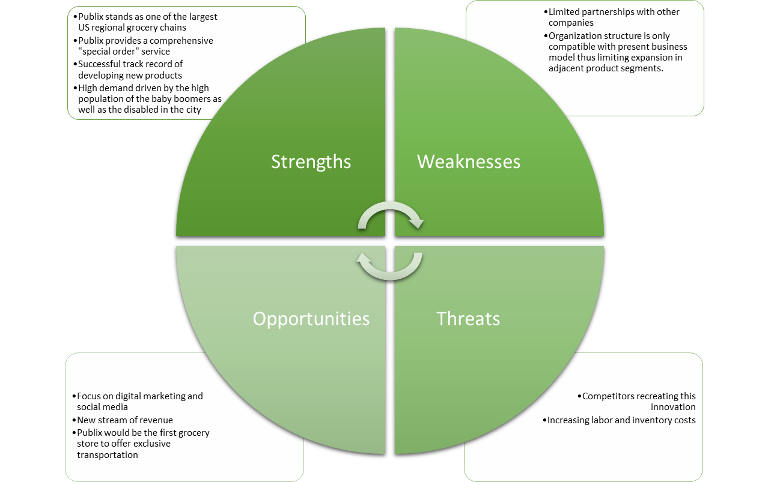
- Threats- The company’s threats are the competitors and for this reason there is need to improve the quality of service to meet customers satisfaction.
Services
The transportation service will cater to the elderly and disabled in the society to meet their needs in the food retail. This transport service if proposed to increase demand of the company’s product as well as increase profits for the company.

Service life cycle

- Exploration stage
At this stage, the business does not expect to get a large number of customers as the population will not have become aware of the added service in the company. At this stage, there is need to create more awareness to the public about the new service.
- Involvement stage
At this stage, all the departments in the organizations are required to take part in creating awareness of the new service in the company with a sole goal to increase awareness about the service and increase demand of the service.
- Development stage
At this stage, the stakeholders can be involved to take part in marketing of the service. By this stage, the company will have a good number of transportation service customers and the number will be increasing due to the marketing strategies already laid.
- Consolidation stage
At this stage, the number of sales will be enough to meet the cost incurred by the service and the company will be making profit. Strategies to increase and maintain the number of customers would also be discussed to meet customers’ satisfaction.
- Stagnation stage
At this stage, the number of demands for customers will not be increasing nor decreasing. The public will already be aware of the new service. Publix will need to analyze strategies to increase demand as well as promotion of return visits for purchase.
- Decline or rejuvenation stage
At this stage, the demand for transport service in the company would increase when rebranding of the service are done, or decline if no strategies are put into practice to increase the purchase of the service.

Management
The transport service will be headed by a transport department that will be developed in the organization n that will have a manger and a vice with transport agents acting as drivers and service men for the transport service in charge for booking and procurement for repair of the vehicles to be used.

Marketing
- Proper market research- Publix will use its competent marketing as well as sales team to market its new service. The marketing team will conduct a primary as well as a secondary research in order to determine the tastes as well as the preferences of its customers in order to advice the responsible transport department.
- The primary research will entail collecting appropriate data from its customers through interviews and online questionnaires. On the other hand, the secondary research will entail the marketing team conducting a review of available literature on marketing.
- Competitors’ analysis- They will also do a research on their competitors to analyze their opportunities and threats I order to gain the competitive edge.
- Online marketing- Publix will use its website to market its new service online. Similarly, the organization will use ads from the local TV and social media platforms to enhance the awareness of its transport service.
Operations plan
Transport service department will develop a website for online booking of the transport service in the Florida city for elderly and disabled
The preferred customer will be required to do online booking and the service delivered within the next 45 minutes from delivery.
The transport services will provide service men who will help the customer in purchase of the goods in the business upon arrival.
Drivers will be required to key in the website as ‘booked’ after the customer books the service for ease of the management to identify how many vehicles are available at a particular time.
At later stages the company will employ more employees to cater for the increasing number of customers if need arises.
The website will have a platform for customers to ports their after service comments for quality service provision as well as meeting the customers’ preferences.

Financial plan
Publix Company will need a total of approximately $ 150,000 to start its transport service operation. That will cover the startup materials, the hiring process, and marketing. $100,000 will be sourced from their account while the rest $50,000 will be acquired as a loan from a local bank.
The company will purchase two vehicles at the first stage and another two after a period of about 4 months checking the progress. The cost of a wheelchair accessible van is about $40,000. So, it will cost $80,000 for the first two vehicles. Some drivers will also utilize their own vehicles for transportation. Insurance will cost about $200-250 per vehicle. To save money, Publix can require rideshare insurance for every delivery driver that uses their own vehicle.
For the hiring process, Publix can hire two full time delivery drivers to drive their accessibility vans. Every other driver can be an independent contractor, so Publix can cut costs.
The subscription will be $29.95 monthly with a two time per week limit for roundtrip rides. There will also be a day pass option for one ride only that will cost $15 for a roundtrip. That will be available for customers who don’t want to pay a subscription or don’t frequent the grocery store that often.
A vehicle will carry a minimum of 4 passengers at a go to minimize the cost as well maximizing the profit to the company.
Action plan
- The transport department manager will be required to forward all the activities run by the department on weekly basis.
- Analysis on the cost incurred will be done monthly, along with the profits, to determine the impact of the transport service introduction to the business.
- Vehicle mileage should be recorded before and after taking any journey during the operation.
Conclusion
Today’s service industry has seen gradual changes in that today customers are aware of what they want and they expect to get quality service from a service provider. Due to this, there is a need for the service provider to do enough market research on the customers’ changing trends in order to satisfy customer needs. For the case of Publix food retailing business, they have gained competitive edge by introducing a supportive service to cater to the elderly and disabled in the society. They are being considerate to the high population of elderly and disabled in Jacksonville and through this, will get more profits from the increased demand of their goods.

Recommendation

- The Publix Company should partner with the transport service providers in Jacksonville to avoid putting a lot of capital in purchase of assets.
- Publix Company should hire independent contractors to lower the hiring costs. If they are an independent contractor, they are required to supply their own vehicle, vehicle rideshare insurance, and gasoline.
- Publix could expand this service to their other locations with a high percentage of elderly and disabled customers in the area.

References

65 and Older Population Grows Rapidly as Baby Boomers Age. The United States Census Bureau. (2020). Retrieved 6 November 2020, from https://www.census.gov/newsroom/press-releases/2020/65-older-population-grows.html.
Ameratunga, S., Spray, J., Anderson, A., Wiles, J., Witten, K., & Ofanoa, M. et al. (2019). Inclusive Streetscapes: Disabled People and Older Citizens Charting a Roadmap to Equity. Journal Of Transport & Health, 14, 100729. https://doi.org/10.1016/j.jth.2019.100729
Bouffard, K. (2020). Publix reports more financial success. Retrieved 6 November 2020, from https://www.theledger.com/news/20200302/publix-reports-more-financial-success.
Connolly, J. (2019). Finding Transportation Services for Seniors. Agingcare.com. Retrieved 6 November 2020, from https://www.agingcare.com/articles/finding-transportation-services-for-seniors-104572.htm.
Disability & Health U.S. State Profile Data: Florida | CDC. Centers for Disease Control and Prevention. (2020). Retrieved 6 November 2020, from https://www.cdc.gov/ncbddd/disabilityandhealth/impacts/florida.html.
Disabled population U.S. by state 2018 | Statista. Statista. (2019). Retrieved 6 November 2020, from https://www.statista.com/statistics/794278/disabled-population-us-by-state/.
Gardner, M. (2020). Council Post: What Are The Implications Of An Aging Population On The Mobility Industry?. Forbes. Retrieved 6 November 2020, from https://www.forbes.com/sites/forbesbusinessdevelopmentcouncil/2020/04/30/what-are-the-implications-of-an-aging-population-on-the-mobility-industry/?sh=482a5b393ebd.
Gleckman, H. (2019). Why Can't We Expand Access To Transportation For Older Adults?. Forbes. Retrieved 6 November 2020, from https://www.forbes.com/sites/howardgleckman/2019/02/18/why-cant-we-expand-access-to-transportation-for-older-adults/?sh=75e2fc6e5c84.
Lee, E., Same, A., McNamara, B., & Rosenwax, L. (2017). An Accessible and Affordable Transport Intervention for Older People Living in the Community. Home Health Care Management & Practice, 30(2), 54-60. https://doi.org/10.1177/1084822317744759
Older Adults & Transportation. National Aging and Disability Transportation Center. (2020). Retrieved 6 November 2020, from https://www.nadtc.org/about/transportation-aging-disability/unique-issues-related-to-older-adults-and-transportation/.
Senior population of the U.S. by state 2019 | Statista. Statista. (2020). Retrieved 6 November 2020, from https://www.statista.com/statistics/736211/senior-population-of-the-us-by-state/.
Shaver, K. (2018). Survey: People with disabilities and the elderly need more help finding transportation services. Retrieved 6 November 2020, from https://www.washingtonpost.com/transportation/2018/12/07/survey-people-with-disabilities-elderly-need-more-help-finding-transportation-services/.
Smialek,, J., Casselman, ,., & Friedman, G. (2020). Workers Face Permanent Job Losses as the Virus Persists. Nytimes.com. Retrieved 6 November 2020, from https://www.nytimes.com/2020/10/03/business/economy/coronavirus-permanent-job-losses.html.
Span, P. (2019). Older People Need Rides. Why Aren’t They Using Uber and Lyft? (Published 2019). Nytimes.com. Retrieved 6 November 2020, from https://www.nytimes.com/2019/08/16/health/uber-lyft-elderly.html.
Su, F., & Bell, M. (2010). Transport for older people: Characteristics and solutions. Research In Transportation Economics, 25(1), 46-55. https://doi.org/10.1016/j.retrec.2009.08.006
Turner, J. (2020). Florida Unemployment Rate At 7.6 Percent As Struggles Continue. Miami.cbslocal.com. Retrieved 6 November 2020, from https://miami.cbslocal.com/2020/10/16/florida-unemployment-rate-struggles-continue/.
Williams, D. (2020). Some grocery stores are offering 'elderly hours' to help protect older shoppers. CNN. Retrieved 6 November 2020, from https://edition.cnn.com/2020/03/16/business/coronavirus-grocery-elder-hours-trnd/index.html

